***Institute of Computer And Technology***

***B.Tech – CSE(BDA)***

***Name:- Dwij Vatsal Desai***

***Sem:- 2***

***Sub: - ESFP-II***

***Enrollment No.:- 23162121027***

***Prac:- 3***

***Date:- 3/2/2024***

**Q.1.**

DMA: Definition: Student Information System.

Lords Universal College, which is situated at Mumbai. College authority decides to come up with a new idea for handling examination section seating arrangements for different-different courses. For that, college wants separate records, those who one is giving a remedial exam for the semester-II. For that, the college wants to take all the information related to students like rollno, name, class, semester, subject, and exam fee. So, whenever is required to search records by id, or by name or by class, he can search randomly and make a proper seating arrangement as per the rules of the examination committee.

So, for the fulfilment of the above said requirement make a proper DMA program using C.

**Algorithm:-**

1. Start

2. Create a structure for entering data about students.

3. Program a code with the use of DMA.

4. Collect the Data from the user.

5. Show the data using printf.

6. Select a person's name.

7. Show the data of the person's name.

8. End

**Code:-**

*#include* <stdio.h>

*#include* <stdlib.h>

*#include* <malloc.h>

*#include* <string.h>

struct Car

{

    int CID;

    char Cname[30];

    char Cprice[20];

    char Ccolor[20];

    struct Car *next;

};

struct Car *newnode, *head = NULL, *end = NULL;

void Last()

{

    newnode = (struct Car *)malloc(sizeof(struct Car));

    printf("Enter the value as: ID of car, Name of car, Price, color of car:-\n");

    scanf("%d %s %s %s", &newnode->CID, newnode->Cname, newnode->Cprice, newnode->Ccolor);

*if* (head == NULL)

    {

        newnode->next = NULL;

        head = newnode;

        end = newnode;

    }

*else*

    {

        end->next = newnode;

        end = newnode;

        end->next = NULL;

    }

}

void display()

{

    struct Car *ttemp;

*if* (head == NULL)

    {

        printf("List is empty\n");

    }

*else*

    {

        printf("\nDisplay value:\n");

*for* (ttemp = head; ttemp != NULL; ttemp = ttemp->next)

        {

            printf("%d %s %s %s\n", ttemp->CID, ttemp->Cname, ttemp->Cprice, ttemp->Ccolor);

        }

        printf("\n");

    }

}

void findProduct()

{

    int choice, id;

    char name[30];

    printf("Enter choice (1 for ID, 2 for Name): ");

    scanf("%d", &choice);

*if* (choice == 1)

    {

        printf("Enter Car ID to find: ");

        scanf("%d", &id);

    }

*else* *if* (choice == 2)

    {

        printf("Enter Car Name to find: ");

        scanf("%s", name);

    }

    struct Car *temp = head;

    int found = 0;

*while* (temp != NULL)

    {

*if* ((choice == 1 && temp->CID == id) || (choice == 2 && strcmp(temp->Cname, name) == 0))

        {

            printf("Car found: %d %s %s %s\n", temp->CID, temp->Cname, temp->Cprice, temp->Ccolor);

            found = 1;

        }

        temp = temp->next;

    }

*if* (!found)

    {

        printf("Car not found.\n");

    }

}

void deleteProduct()

{

    int choice, id;

    char name[30];

    printf("Enter choice (1 for ID, 2 for Name): ");

    scanf("%d", &choice);

*if* (choice == 1)

    {

        printf("Enter Car ID to delete: ");

        scanf("%d", &id);

    }

*else* *if* (choice == 2)

    {

        printf("Enter Car Name to delete: ");

        scanf("%s", name);

    }

    struct Car *temp = head;

    struct Car *prev = NULL;

*while* (temp != NULL)

    {

*if* ((choice == 1 && temp->CID == id) || (choice == 2 && strcmp(temp->Cname, name) == 0))

        {

*if* (prev == NULL)

            {

                head = temp->next;

            }

*else*

            {

                prev->next = temp->next;

            }

            free(temp);

            printf("Car deleted successfully.\n");

*return*;

        }

        prev = temp;

        temp = temp->next;

    }

    printf("Car not found.\n");

}

int main()

{

    int a = 0;

*for* (;;)

    {

        printf("Press <1> to add value at end \n");

        printf("Press <2> to display value \n");

        printf("Press <3> to find car \n");

        printf("Press <4> to delete car \n");

        printf("Press <5> to end code \n");

        printf("\nEnter number for menu:  ");

        scanf("%d", &a);

*switch* (a)

        {

*case* 1:

            int num_Car;

            printf("\nHow many units do you want: ");

            scanf("%d", &num_Car);

*for* (int i = 0; i < num_Car; i++)

            {

                Last();

            }

*break*;

*case* 2:

            display();

*break*;

*case* 3:

            findProduct();

*break*;

*case* 4:

            deleteProduct();

*break*;

*case* 5:

*return* 0;

*default*:

            printf("Enter right number\n");

*break*;

        }

    }

*return* 0;

}

***Output-***

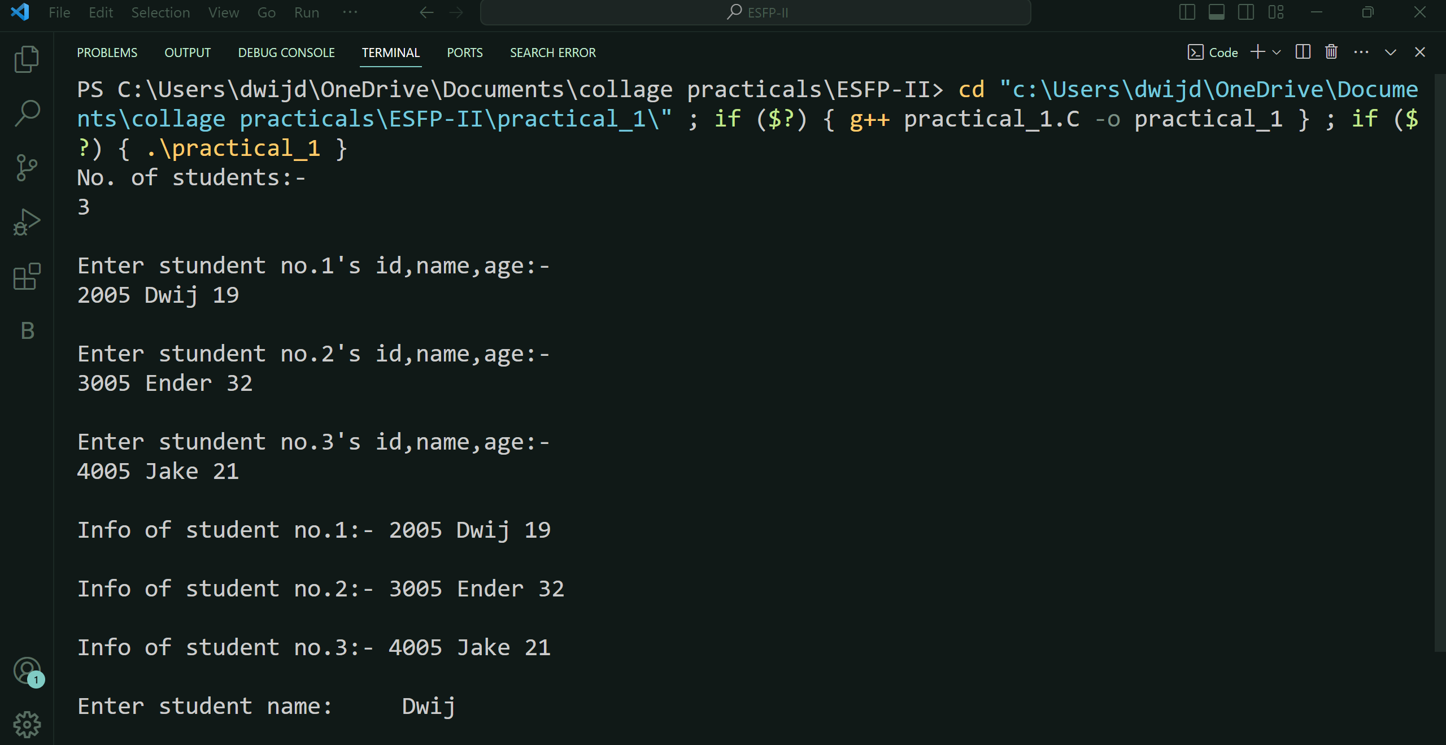

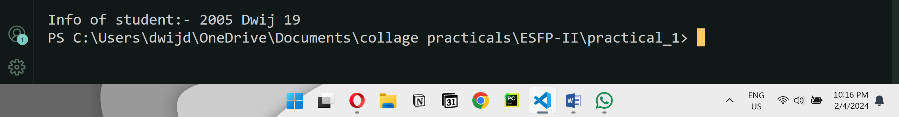

***Photo of code:-***

